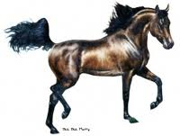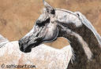
******************************************************************************
*Novice Classes: Open to those who have not won three first place ribbons in that division.
*Horizon Classes: Open to non-professional, inexperienced riders or handlers starting to show.
*Exceptional Rider: Rider with disability. Side walkers/leaders allowed.
*Optional Equipment: Exhibitors may show in Western, English or Hunt equipment. (Doesn’t
mean training equipment.)
*Ring Issues: The Judge has final call.
*Show Manager may add or delete classes the day of the show.
*****************************************************************************
Office Fee $10.00 per rider, Class Fee $10.00 per rider per class
Stalls: $60.00, Bedding $10.00, Move in time Friday afternoon 3PM
For Stall Reservations and Bedding contact: Dawn Ackerson (515)669-7457
Show Managers: Rick and Dawn Ackerson, AckersonArabians@gmail.com
Camping Available

